**Exercise – 1**

**1.**  Identify the first 2 packets (i.e. their packet numbers) containing HTTP GET request.

Ans: The two packets containing HTTP GET request are: packet no. 7 and 39.

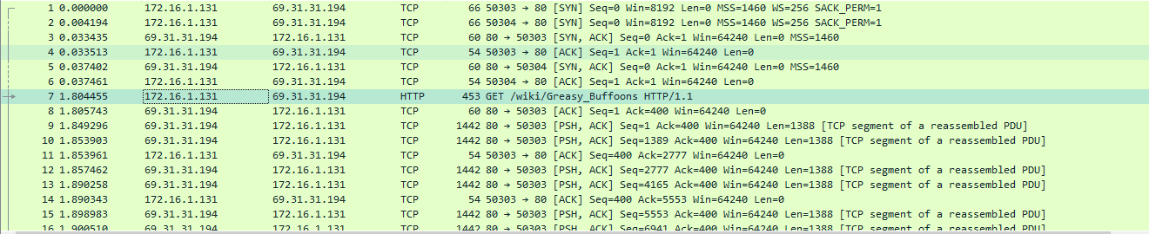

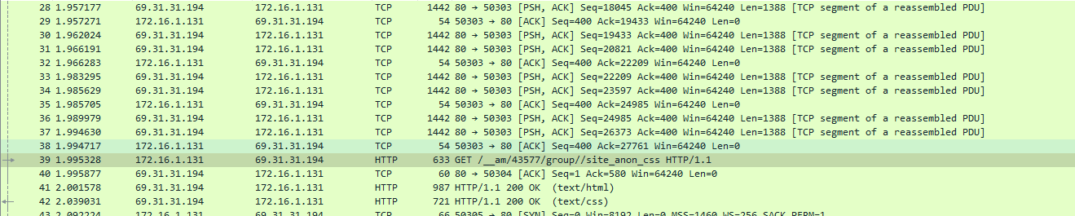

**2.** What webpage was visited in the above 2 packets?

Ans: Packet no. 7 visited the website spongebob.wikia.com\r\n and packet no. 39 visited spongebob.wikia.com\r\n.

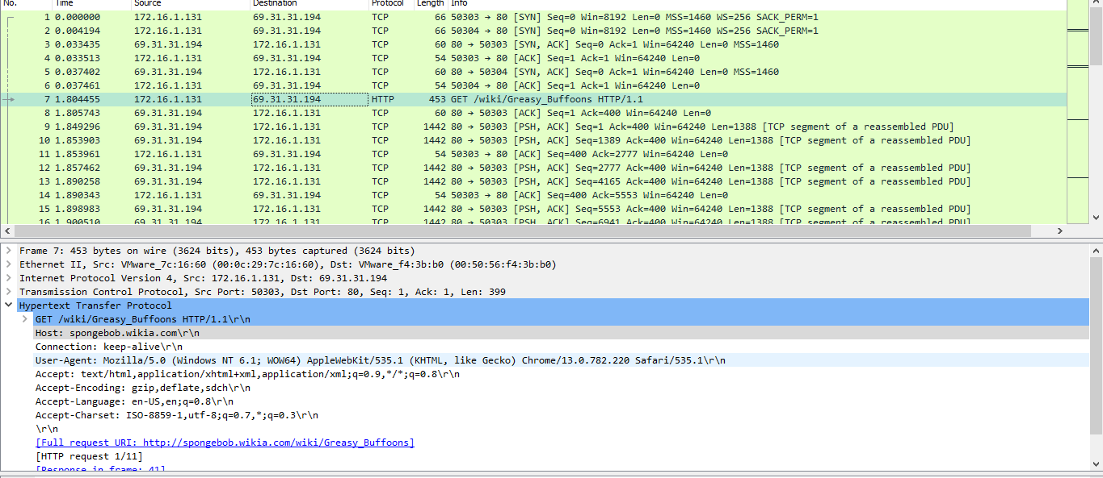

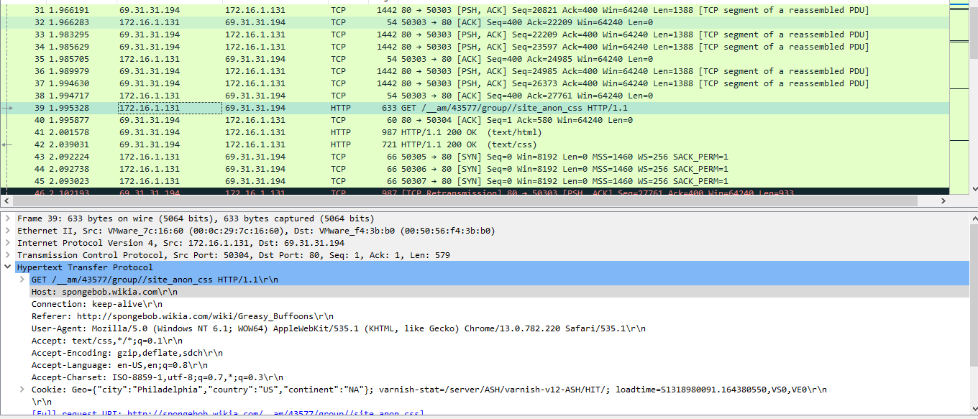

**3.** What version of HTTP was used?

Ans: The version used for HTTP was HTTP/1.1.

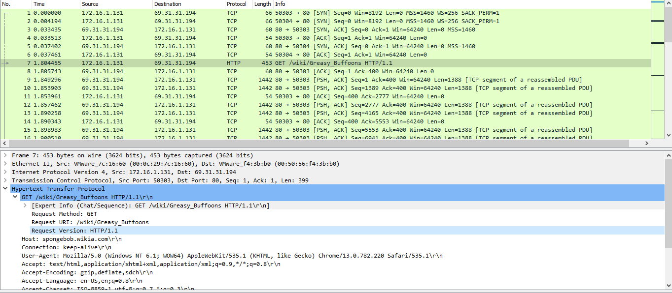

**4.** What is the destination IP address in the above packets?

Ans: The destination IP address for packet 7 is: 69.31.31.194.

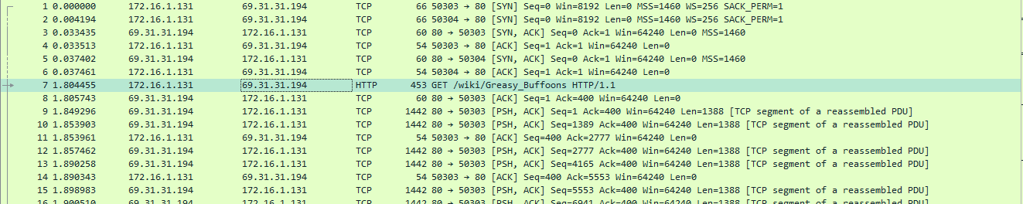

The destination IP address for packet 39 is: 69.31.31.194.

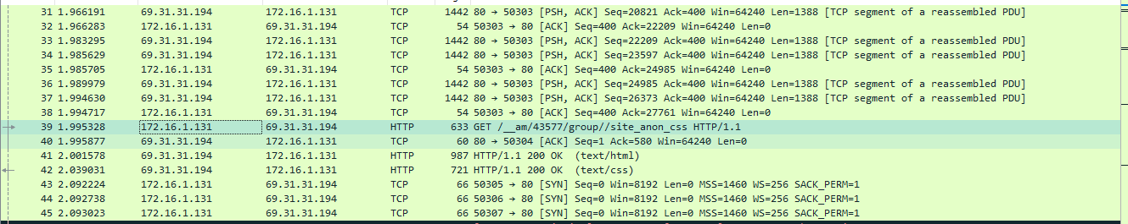

**5.** List the source and destination ports of the packet travelling from the client to the server in the above packets?

Ans: The source and destination port of packet 7 are as follows: source: 50303, dest: 80

The source and destination port of packet 7 are as follows: source: 50303, dest: 80

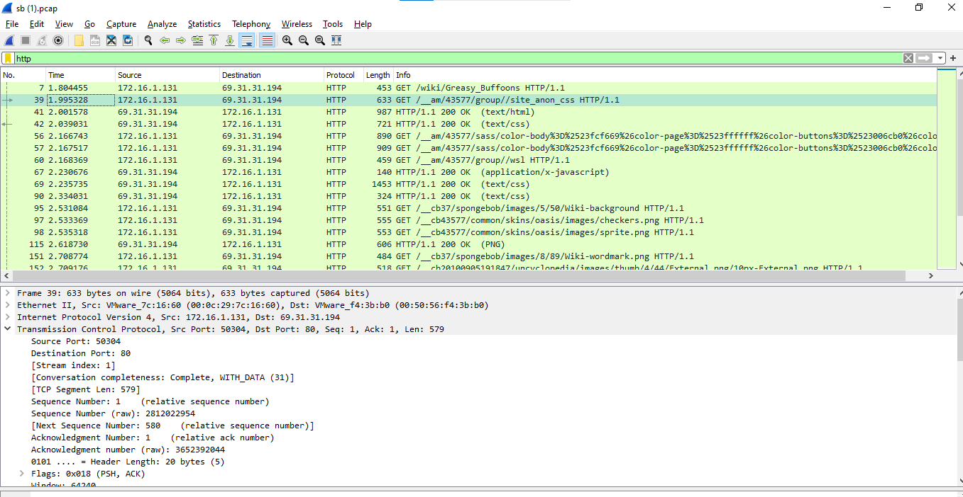

**6.** In the HTTP server’s response, look at the information sent about the server. What server software was used?

Ans: The server used is Apache\r\n

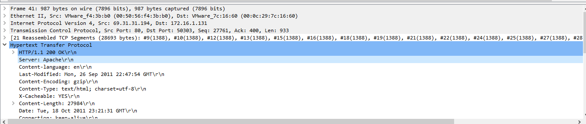

**7.** What are the IP address of the server?

Ans: The IP address of the server is: 172.16.1.131

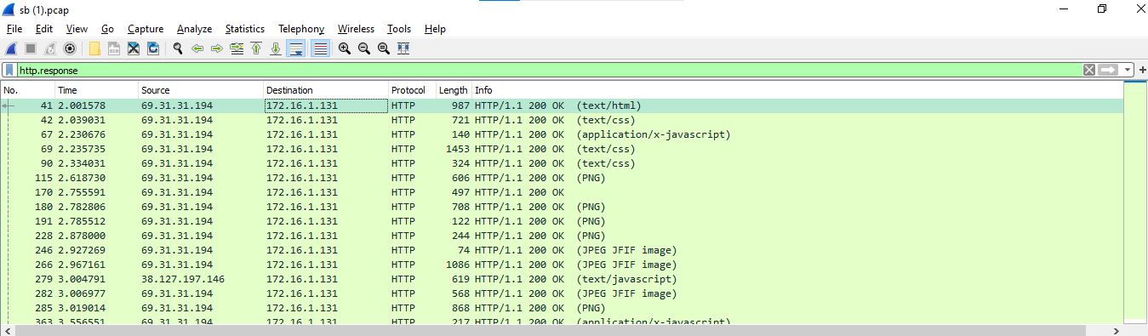

**8.** What are the MAC address of the client and the server?

Ans: The MAC of the client and server are as follows:

client: 7c:16:60 (00:0c:29:7c:16:60)

destination: f4:3b:b0 (00:50:56:f4:3b:b0)

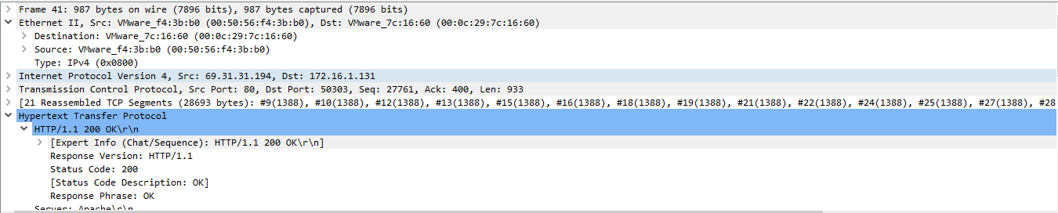

**9.** How many web pages have been opened?

Ans: Total 8 web pages have been opened.

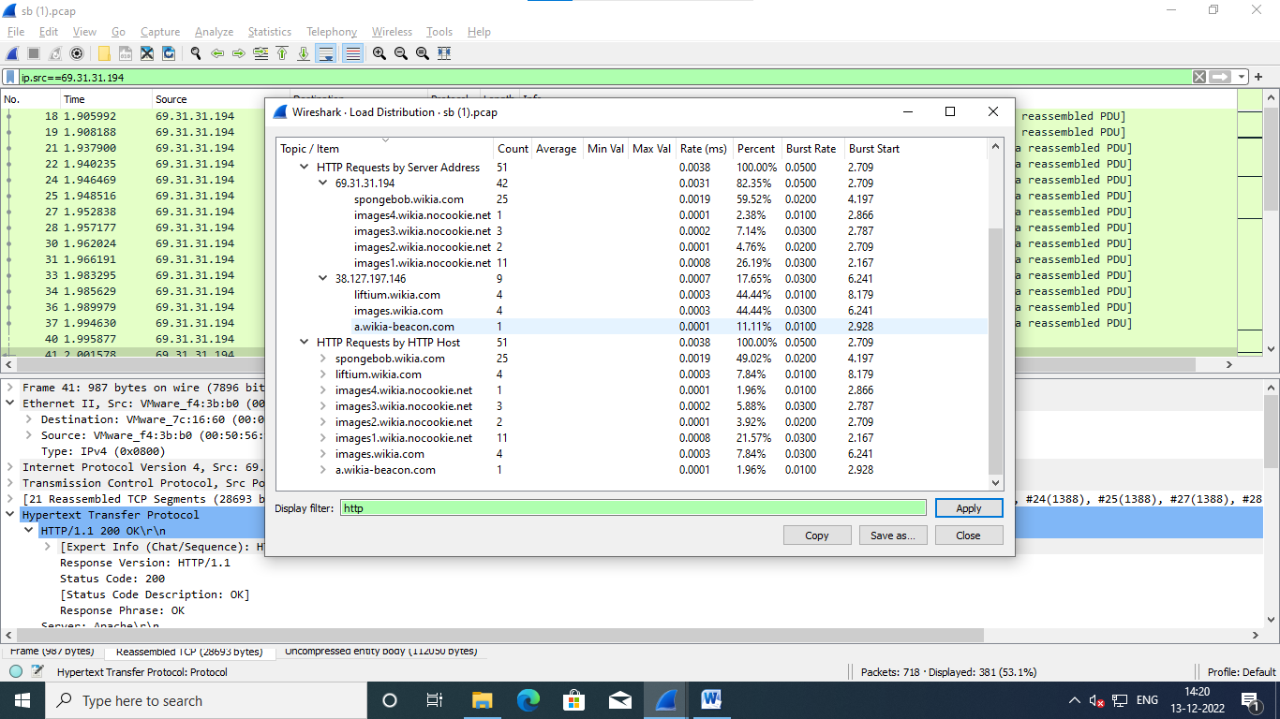

**10.** What is the time different between first HTTP GET and the first HTTP responce (OK)?

Ans: The time difference between first HTTP GET and the first HTTP responce (OK) is: 0.197123.

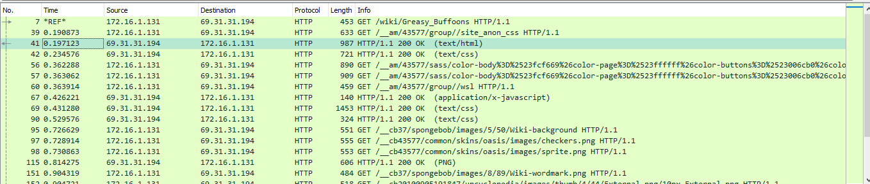

**11.** Count the total number of HTTP get request.

Ans: The total no. of HTTP GET request are 51.

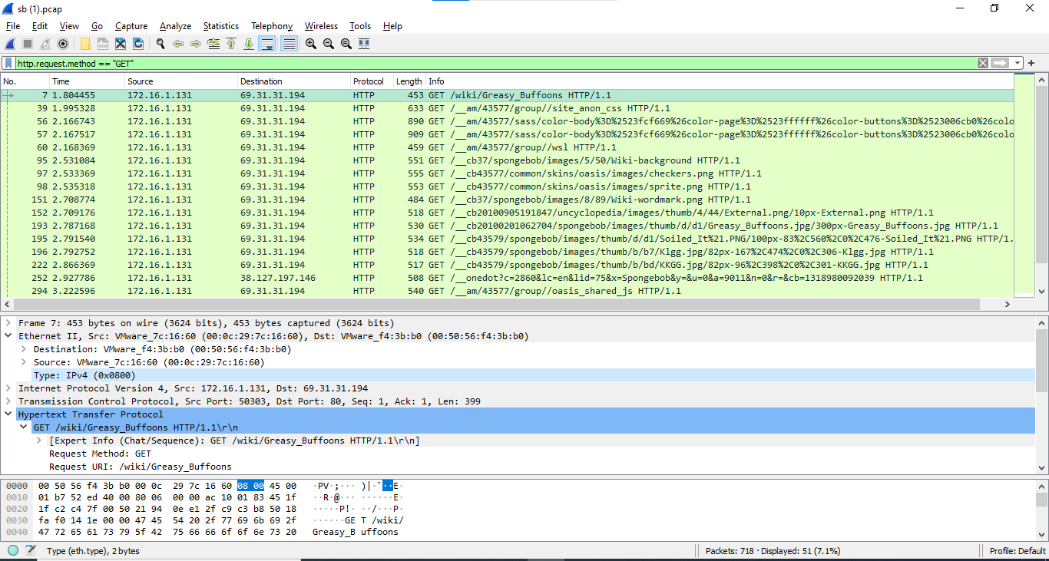

**12.** What is the time difference between the first and last HTTP GET request?

Ans: The time difference between the first and the last HTTP GET request is: 13.349456

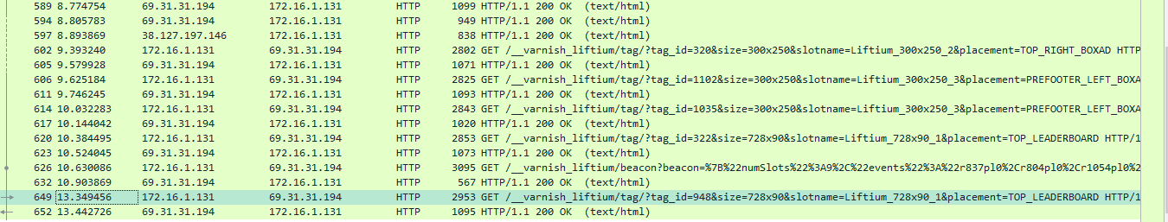

**13.** How many packets were exchanged between the server and the client?

Ans: The total no. of packets exchanged between the client and server are: 718

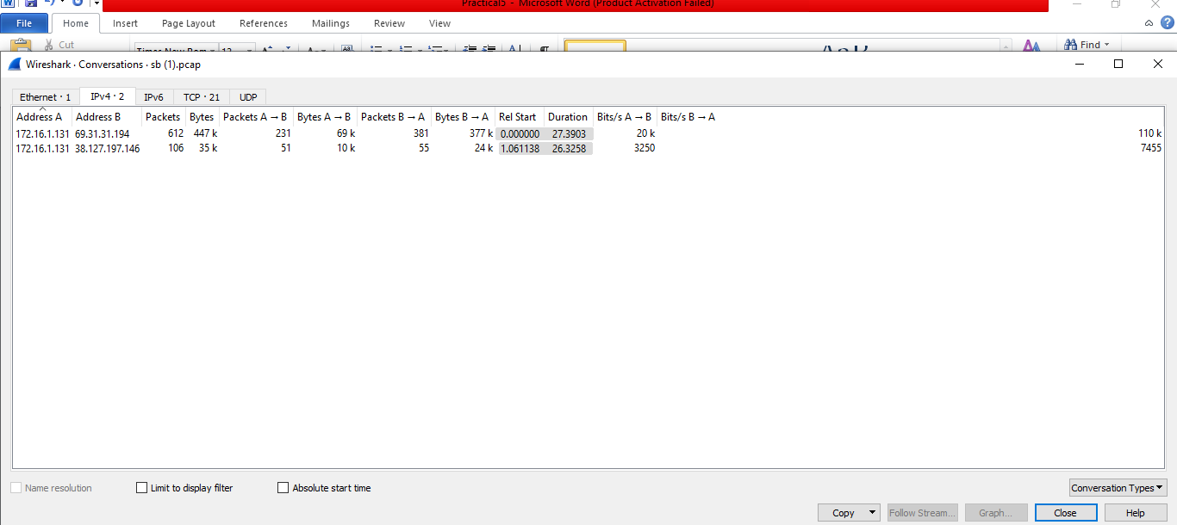

**14.** Find the total no. of HTTP request sent by the host spongebob.wikia.com.

Ans: The total no. of HTTP request sent by the host spongebob.wikia.com are: 25.

